# **📘 Correlation in JMeter**

Making Test Scripts Dynamic, Reliable, and Scalable

## **🎯 What is Correlation?**

**Correlation** is the process of **extracting dynamic values** (like session IDs, tokens, unique keys) from a server’s response and **reusing** them in subsequent requests.

Without it, your test may:

* Replay expired or invalid data
* Fail with errors (401 Unauthorized, 403 Forbidden, etc.)
* Misrepresent real-world behavior

## **🤔 Why is Correlation Necessary?**

| **🌐 Scenario** | **📉 What Happens Without Correlation** |
| --- | --- |
| Login → Session ID | Hardcoded session fails on next run |
| CSRF Token in Form | Server rejects reused token |
| Dynamic Product ID | Server cannot locate product |
| Checkout with Transaction ID | Duplicate or invalid transaction |

## **🛠️ Correlation Flow in JMeter**

### **Step 1: 🔍 Extraction**

Use **Post-Processors** to extract values from server response (HTML, JSON, XML).

### **Step 2: 🔁 Replacement**

Use the extracted variable (e.g., ${sessionId}) in future HTTP requests.

## **🧰 Common Post-Processors for Correlation**

### **1️⃣ 🧩 Regular Expression Extractor (Most Common)**

**Purpose**: Extracts dynamic values from text responses (HTML, headers, etc.)

| **Field** | **Example** |
| --- | --- |
| Reference Name | csrfToken |
| Regex | name="csrf_token" value="(.+?)" |
| Template | $1$ |
| Match No. | 1 |
| Default Value | NOT_FOUND |

✅ Use in request: csrf_token=${csrfToken}

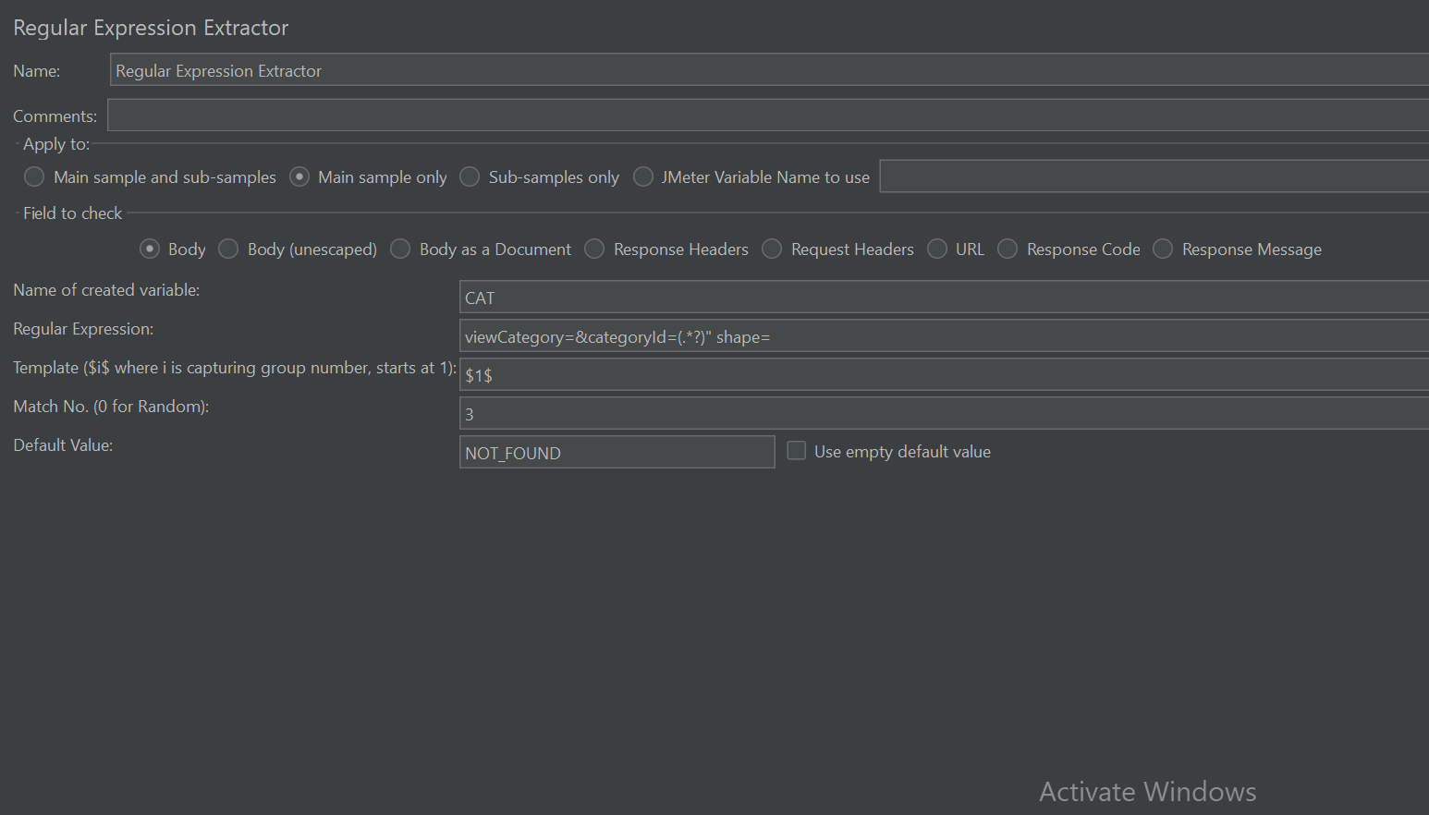

### **2️⃣ 🎯 JSON Extractor**

**Purpose**: Extracts values from JSON responses using **JSONPath**

| **Field** | **Example** |
| --- | --- |
| Variable Name | sessionKey |
| JSONPath Expression | $.sessionKey |
| Match No. | 1 |

✅ Use in request: Authorization: Bearer ${sessionKey}

### **3️⃣ 🎨 CSS Selector Extractor**

**Purpose**: Extracts HTML content using CSS-style selectors

| **Field** | **Example** |
| --- | --- |
| Reference Name | productID |
| CSS Selector | #productDetails .productId |
| Attribute | text |

✅ Use: productId=${productID}

### **4️⃣ 📜 XPath Extractor**

**Purpose**: Extracts XML values using XPath expressions

| **Field** | **Example** |
| --- | --- |
| Reference Name | userId |
| XPath Query | //userId/text() |

✅ Use: user=${userId}

## **🧪 Manual Correlation: Step-by-Step**

### **✅ Step 1: Record Script**

Use JMeter’s **HTTP(S) Test Script Recorder** or **BlazeMeter Chrome Plugin**.

### **✅ Step 2: Identify Dynamic Values**

Compare 2 recordings and inspect:

* View Results Tree → Response Data
* Look for: sessionID, authToken, productId, etc.

### **✅ Step 3: Add Post-Processor Extractor**

Add to the **request that generates the value**:

text

CopyEdit

Thread Group

└─ HTTP Request (Login)

└─ Regular Expression Extractor (sessionId)

### **✅ Step 4: Replace Hardcoded Values**

Use ${variableName} in all subsequent requests.

### **✅ Step 5: Validate**

* Run 1 user, 1 iteration
* Use **View Results Tree** to confirm:  
  + Extracted value exists
  + Subsequent requests use it correctly

## **🛠️ Example – Correlating CSRF Token**

**Server Response**:

html

CopyEdit

<input type="hidden" name="csrf_token" value="aBc123XyZ"/>

**Extractor**:

* Reference Name: csrfToken
* Regex: name="csrf_token" value="(.+?)"
* Template: $1$

**Subsequent Request**:

ini

CopyEdit

csrf_token=${csrfToken}

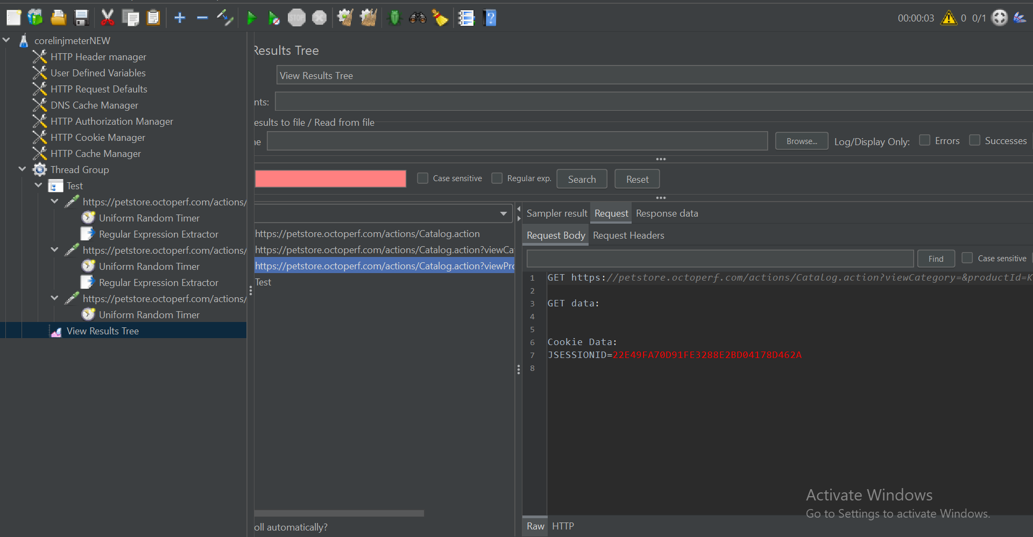

## **🧩 Extractor Comparison Table**

| **Extractor** | **Input Format** | **Syntax** | **Best Use Case** |
| --- | --- | --- | --- |
| Regex Extractor | HTML, Text, XML | (.+?) | CSRF, session IDs |
| JSON Extractor | JSON | $.data.id | Tokens, product IDs in APIs |
| CSS Extractor | HTML | .class, #id | Structured HTML, visible content |
| XPath Extractor | XML, XHTML | //tagname/text() | SOAP/XML-based services |

## **🧠 Tips for Effective Correlation**

* Use **View Results Tree > Response Data** to test your extractors
* Use **RegEx Tester** or [JSONPath Online Evaluator](https://jsonpath.com/)
* Always define a **Default Value** to debug failed matches
* Use ${variableName} correctly – spelling/format matters!
* Combine extractors with **Debug Sampler** to see what’s being captured

## **🚀 Auto-Correlation Tools**

### **🔧 BlazeMeter SmartJMX**

Auto-detects correlation during recording, suggests extractors.

### **🔌 JMeter Correlation Recorder Plugin**

Suggests extractors and automates parameter substitution.

⚠️ Still requires manual review for accuracy.

## **⚠️ Common Mistakes to Avoid**

| **Mistake** | **Impact** |
| --- | --- |
| Using hardcoded dynamic data | Requests fail after first replay |
| Incorrect regex or path | Variable stays empty |
| Missing match group/template | ${varName} resolves as blank |
| Wrong response field checked | Extractor doesn’t find the value |

## **✅ Correlation Checklist**

✅ Identify the dynamic value  
 ✅ Locate the request that returns it  
 ✅ Attach appropriate extractor  
 ✅ Reference variable in subsequent request  
 ✅ Validate extraction & usage via debug or results tree